Thank you for buying the **Paper man | Hyper-Casual Characters**, we hope it will help you in your project.

If you liked our product, do not forget to rate it in an Asset store: <https://u3d.as/2GpD>

Your feedback will help me improve the project.

If you have any suggestions or questions, you can write to this email: [*pirate.parrot.software@gmail.com*](mailto:pirate.parrot.software@gmail.com)

**How to use Humanoid animation?**

1. Find the animation you need on the website <https://www.mixamo.com> and download it with the following settings:

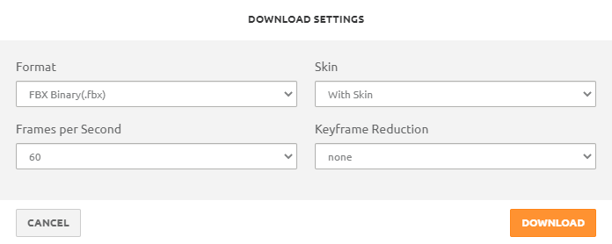

1. Import the animation into your Unity project.
2. Select animation in Unity. In the Inspector window, on the Rig tab, change the Animation Type to Humanoid. Apply.

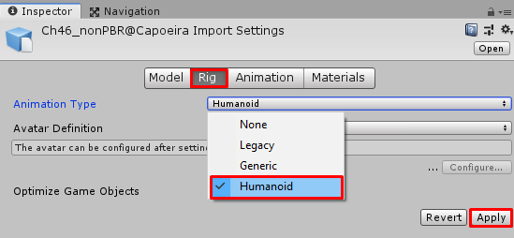

1. Make sure your model is also set to Humanoid Animation Type:

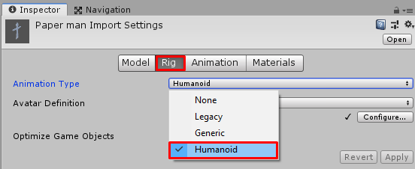

**List of animations used in the** [**Video**](https://youtu.be/OJo7GH87Xvg)

**Dance:**

Hokey Pokey

Rumba Dancing

Salsa Dancing

**Idle:**

Arm Stretching

Idle

Shaking Hands 2

**Running:**

Goofy Running

Running

Running Forward Flip